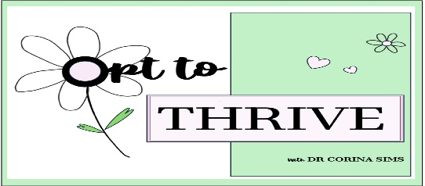

**Perimenopause, Menopause, Post-menopause**

**Menopause** is really just one day in time which signifies the end of our reproductive capability. We are born with all of the eggs in our ovaries that we are ever going to have. Our eggs are constantly undergoing a process of development and loss which starts even before we are born. Then over the years we continually lose them until they are all gone. Each month from the time we start to menstruate our bodies are preparing an egg to ovulate. Menopause occurs when our eggs are completely gone. It is diagnosed when we have not had a menstrual period for 12 months and there is no other reason for this to be occurring.

By the time a woman turns 30 she has roughly 10% of her eggs left. At 40 years old this number drops to around 3%. As the number of eggs decreases it become harder and harder for the body to prepare a quality egg for ovulation. Hormones begin to fluctuate, sometimes wildly, which can result in multiple symptoms such as:

* Irregular periods
* Heavier or lighter menstrual bleeding
* Shorter or longer periods
* Headaches
* Sore breasts
* Headaches
* Hot flushes
* Night sweats
* Sleep disturbance
* Mood changes
* Fatigue
* Brain fog
* Low libido
* Muscle and/or joint aches
* Vaginal dryness
* Urinary symptoms
* Painful intercourse

The timeframe where these symptoms occur leading up to the final menstrual period makes up the **perimenopause**. It is not unheard of for these symptoms to start as early as 35 years old. Some women have no symptoms. The majority of women will have mild to moderate symptoms. About 20% of women will have severe symptoms. The symptoms usually last between 4 and 8 years however they can be present for as little as a few months to as long as 10 years.

Every day after that one day in time we call menopause, is known as **post-menopause**. Symptoms can continue into post-menopause for another 10 years or more.